 SEMINAR REPORT 

A seminar Report on
Smart waste and Sanitation Issue Reporting System
Submitted partial fulfilment for the award of
THIRD YEAR DIPLOMA IN
COMPUTER ENGINEERING
By
Sr. No | Enrollment Number | Seat  Number | Name of student
1 | 25610960017 | 388612 | Yukta Subhash Jawadekar
2 | 25610960007 | 388605 | Diksha Subhash Jagtap
3 | 25610960011 | 388609 | Sneha Ransing Girase
4 | 25610960006 | 388604 | Vaishnavi Kashinath Ahire

FOR THE ACADEMIC YEAR: 2026 – 2027

DEPARTMENT OF COMPUTER ENGINEERING
S.S.V.P. S’s Bhausaheb Shivajirao Deore Polytechnic, Dhule (Institute Code: 0059)

S.S.V.P.S's Bapusaheb Shivajirao Deore Polytechnic, Dhule
(An Affiliated Institute of Maharashtra State Board of Technical Education)
DEPARTMET OF COMPUTER ENGINEERING

CERTIFICATE
Sr. No | Enrollment Number | Seat  Number | Name of student
1 | 25610960017 | 388612 | Yukta Subhash Jawadekar
2 | 25610960007 | 388605 | Diksha Subhash Jagtap
3 | 25610960011 | 388609 | Sneha Ransing Girase
4 | 25610960006 | 388604 | Vaishnavi Kashinath Ahire

of CO5K Semester of Diploma in Computer Engineering of S.S.V.P.S’s B. S. Deore Polytechnic, Dhule (Inst.Code: 059) has completed the term work satisfactorily in Course
Seminar Presentation and Project Initiation (Course Code: 315003) for the academic year 2026 to 2027 as prescribed in the curriculum.

Place: Dhule
Date: 17/10/2026

Signature: Signature:
Name : Mr Nishad .D. Patel Name : Mr Nishad .D. Patel

Subject Teacher Head of the Department

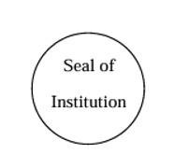

TABLE OF CONTENT
Sr. No. | Chapter | Page No.
 | Abstract | i
 | List of Figures | ii
 | List of Tables | iii
1 | Introduction | 1
2 | Literature Review | 2
3 | Information/Chapters | 3
4 | Advantages and Disadvantages | 8
5 | Conclusion | 9
6 | Project Initiation: | 10
6 | 6.1) Description of problem statement. | 10
6 | 6.2) Scope and objectives. | 10
6 | 6.3) Stake holder | 11
6 | 6.4) Platform/ Equipment/ Resources identification. | 12
7 | Seminar Presentation
 | Bibliography
 | References

ABSTRACT
Smart Waste and Sanitation Issue Reporting and Resolution System (SNAPFIXIT)
Waste management and sanitation are major challenges in maintaining clean and healthy public spaces. Traditional methods of reporting issues such as overflowing dustbins, garbage accumulation, blocked drainage systems, and unclean public areas can be time-consuming and may lack proper complaint tracking. To overcome these challenges, this project proposes SNAPFIXIT, a web-based Smart Waste and Sanitation Issue Reporting and Resolution System The system allows citizens to report waste and sanitation-related issues by submitting photographs and providing location details. The submitted complaints are recorded in the system and can be managed by the concerned authorities through a centralized dashboard. Citizens can track the status of their complaints, while administrators can monitor reported issues and update their progress as pending, in progress, or resolved The main objective of SNAPFIXIT is to simplify the complaint reporting process, improve communication between citizens and municipal authorities, and support efficient sanitation management. The system aims to promote transparency, accountability, and community participation in maintaining clean surroundings. In the future, additional features such as GPS-based location tracking, voice-based reporting, and real-time notifications can be incorporated to improve its functionality.

i

LIST OF FIGURES

Fig. No. | Title | Page No.
3.1 | Flowchart of SNAPFIXIT Smart Waste and Sanitation Issue Reporting System | 8
3.2 | System Architecture of Argument Reality In Education | 10

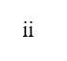

LIST OF TABLES

Table No. | Title | Page No.
2.1 | Literature review | 5
5.3 | Stakeholders and Their Roles in the SNAPFIXIT System | 5
3.1 | Software and Resources Required for the SNAPFIXIT System | 14

iii

CHAPTER 1

INTRODUCTION
Waste management and sanitation play an important role in maintaining a clean, healthy, and sustainable environment. In many urban and rural areas, problems such as overflowing dustbins, garbage accumulation, blocked drainage systems, and unclean public places are common. These issues can create an unhealthy environment and affect the quality of life of citizens. Traditional methods of reporting such problems often involve direct communication with municipal authorities or manual complaint registration, which may be time-consuming and make it difficult to track the progress of complaints.
To overcome these challenges, SNAPFIXIT – Smart Waste and Sanitation Issue Reporting and Resolution System is proposed as a web-based solution. The system provides a convenient platform for citizens to report waste management and sanitation issues by submitting photographs and relevant location details. The submitted complaints can be recorded, monitored, and managed through a centralized system. The concerned authorities can review complaints, update their status, and take appropriate action to resolve the reported problems.
SNAPFIXIT aims to improve communication between citizens and municipal authorities by providing a simple and organized complaint management process. It helps users monitor complaint progress and enables administrators to manage reported issues more efficiently. By improving transparency, accountability, and public participation, the system supports better sanitation management and cleaner surroundings.
The proposed system focuses on making complaint registration and tracking easier through digital technology. In the future, features such as GPS-based location tracking, real-time notifications, and data analysis can be added to enhance the system's functionality. Overall, SNAPFIXIT aims to contribute to cleaner communities and more effective waste and sanitation management.

CHAPTER 2

LITERATURE REVIEW
This section summarizes selected research papers related to Smart Waste and Sanitation Issue Reporting and Resolution Systems. The reviewed studies focus on web-based complaint registration, photograph submission, location tracking, complaint management, and digital solutions for improving sanitation services.

- Sarvagod et al. (2026)

Ayush Sarvagod, Aniket Tavar, Jishan Pathan, and Prof. Kanchanmala More, in their research paper titled “Smart Sanitation Complaint System Using QR Code, GPS Tracking, and Real-Time Image Verification,” presented a web-based platform for reporting sanitation problems. The system allows citizens to submit photographs and location details, while authorities can manage complaints through a dashboard. This study is directly relevant to SNAPFIXIT because it focuses on digital sanitation reporting and complaint management.

- Guledgudd et al. (2026)

Dr. Tabasum Guledgudd, Gurusiddappa Hugar, Aditya Singh R. S., Kiran Ganta, Girish C. Patil, and Manjunath Patakare, in their paper titled “Smart Garbage Management System: A Web-Based Citizen Complaint and Administrative Resolution Platform,” proposed a web-based system for reporting and managing garbage-related complaints. The platform supports photograph-based complaint submission and provides an administrative dashboard for monitoring and resolving reported issues. This research is relevant to SNAPFIXIT because it demonstrates how a centralized web application can improve waste complaint management.

- Jadhav et al. (2025)

Abhijit D. Jadhav, Anurag Raut, Shreyash Mundokar, Sohan Yeole, and Anshu Yadav, in their paper titled “Citizen Complaint Redressal and Infrastructure Management System,” proposed a web-based platform for managing public infrastructure complaints in the Pune Metropolitan Region. The system addresses problems such as garbage disposal, drainage blockages, and damaged infrastructure. It focuses on centralized complaint management and status monitoring. This study provides a useful reference for SNAPFIXIT's approach to reporting and managing public sanitation issues.

- Sudha et al. (2026)

Sudha N., Nithya R., Subasri M., and Supritha R., in their research paper titled “Crowdsourced Civic Issue Reporting and Resolution System,” proposed a digital platform that enables citizens to report civic problems using images, descriptions, and location details. The system stores complaints in a centralized database and provides a dashboard for authorities to monitor reported issues. This research is related to SNAPFIXIT because it emphasizes citizen participation, complaint tracking, and transparent issue management.

- Kushal et al. (2026)

Kushal R., B. Sudharshan Reddy, K. Muni Shankar, B. Jyothi Chowdary, and Prof. Spandana S. G., in their paper titled “Community Cleanliness Complaint App – Android Application for Swachhta and LiFE,” presented a digital application for reporting and managing community cleanliness issues. Citizens can submit complaints with images and location details, while authorities can track and resolve the reported problems. This study highlights the importance of digital reporting and citizen participation in maintaining clean surroundings. Its complaint management approach is relevant to the objectives of SNAPFIXIT.

- Jiao et al. (2024)

Yaran Jiao, Chunming Li, Ziyan Yao, Chen Weng, Anxin Lian, and Rencai Dong, in their research paper titled “How Can Online Citizen Complaints Provide Solutions to Refine Environmental Management: A Spatio-Temporal Perspective,” studied how online citizen complaints can support environmental management. The researchers analyzed environmental complaints to understand their geographical distribution, timing, and impact on management decisions. This study is relevant to SNAPFIXIT because it highlights the importance of collecting citizen complaints and using complaint records to identify environmental problems.

- Jadhav et al. (2025)

Abhijit D. Jadhav, Anurag Raut, Shreyash Mundokar, Sohan Yeole, and Anshu Yadav, in their research paper titled “Citizen Complaint Redressal and Infrastructure Management System,” proposed a web-based platform for reporting public infrastructure problems. The system supports reporting issues such as garbage disposal problems, drainage blockages, and damaged roads. It provides centralized complaint management and status tracking for authorities. This study is relevant to SNAPFIXIT because it demonstrates how a digital platform can simplify public issue reporting and improve transparency.

- Raj and Kumar (2025)

Sunny Raj and Aryan Kumar, in their research paper titled “Digital Grievance Redressal for Cleaner, Smarter India,” discussed a centralized digital platform for reporting civic problems, including waste mismanagement and poor sanitation. The proposed platform focuses on structured complaint registration, tracking, and communication with the concerned authorities. The study highlights the importance of transparency and accountability in public grievance management. These concepts support the objectives of SNAPFIXIT.

9.Guledgudd et al. (2026)
Dr. Tabasum Guledgudd, Gurusiddappa Hugar, Aditya Singh R. S., Kiran Ganta, Girish C. Patil, and Manjunath Patakare, in their research paper titled “Smart Garbage Management System: A Web-Based Citizen Complaint and Administrative Resolution Platform,” proposed a centralized web application for reporting garbage-related problems. Citizens can submit image-supported complaints, while administrators can monitor, assign, and manage reported issues through a dashboard. This study is closely related to SNAPFIXIT because it focuses on web-based complaint registration and administrative resolution.

- Sarvagod et al. (2026)

Ayush Sarvagod, Aniket Tavar, Jishan Pathan, and Prof. Kanchanmala More, in their research paper titled “Smart Sanitation Complaint System Using QR Code, GPS Tracking, and Real-Time Image Verification,” presented a web-based system for reporting sanitation problems. The platform supports photograph submission, location identification, and complaint routing to the relevant authorities. This research demonstrates how digital reporting tools can make sanitation complaint management more organized and efficient. It provides useful reference material for the reporting and tracking functions of SNAPFIXIT.

Table No 2.1: Literature review
Sr. No. | Approach Type | Technologies Used | Dataset | Key Objective | Limitations
1 | Web-based waste management system | HTML, CSS, JavaScript, Database | Waste and sanitation complaints | To provide an online platform for reporting waste-related issues. | Requires internet access and regular complaint updates.
2 | Citizen complaint reporting system | Web application, Image Upload, Database | Citizen-submitted complaints | To simplify complaint registration and improve communication with authorities. | Resolution depends on timely action by responsible authorities
3 | GPS-based sanitation reporting | GPS, Web Technology, Maps | Location-based sanitation reports | To identify the location of reported sanitation problems. | GPS accuracy may vary, and location permission is required
4 | Digital complaint tracking system | Web Dashboard, Database | Complaint records and status updates | To help citizens track complaints and administrators monitor progress. | Depends on accurate and timely status updates.
5 | Smart garbage monitoring system | Sensors, IoT, Web Dashboard | Dustbin fill-level readings | To monitor dustbin status and support efficient waste collection | Requires sensors, hardware installation, and maintenance.

CHAPTER 3

INFORMATION ON SEMINAR

1.1 Web-Based Waste Management System
A web-based waste management system provides an online platform for reporting and managing waste-related problems. Citizens can access the system through a web browser and report issues such as overflowing dustbins, garbage accumulation, and unclean public places. It helps maintain digital records and improves communication between citizens and the concerned authorities.
1.2 Sanitation Issue Reporting System
A sanitation issue reporting system allows users to report problems related to cleanliness and public sanitation. Users can submit issue descriptions, photographs, and other relevant details. The submitted information helps authorities understand the problem and take appropriate action to resolve it.
1.3 Photograph-Based Complaint Reporting
Photograph-based complaint reporting allows citizens to upload images of waste and sanitation problems. These images provide visual evidence of the reported issue and help administrators understand the condition of the affected area. This feature makes complaint reporting more informative and easier to manage.
1.4 Complaint Tracking and Management
Complaint tracking and management help users and administrators monitor the progress of reported issues. Complaints can be organized according to their status, such as Pending, In Progress, and Resolved. This process helps maintain organized records and improves transparency in complaint handling.
1.5 Centralized Administration Dashboard
A centralized administration dashboard provides a common interface for administrators to view and manage submitted complaints. Administrators can review complaint details, update status information, and monitor reported sanitation issues. It helps organize complaint records and supports efficient management of public cleanliness problems.

1.6 Working Principle
The working principle of SNAPFIXIT is based on digital complaint registration and management. First, the user accesses the web application and identifies a waste or sanitation issue. The user then submits the complaint along with a photograph and relevant details. The complaint information is recorded in the system and made available for administrative review. The administrator checks the complaint, updates its status, and takes the necessary steps for resolution. Users can monitor the complaint progress according to the features available in the system.

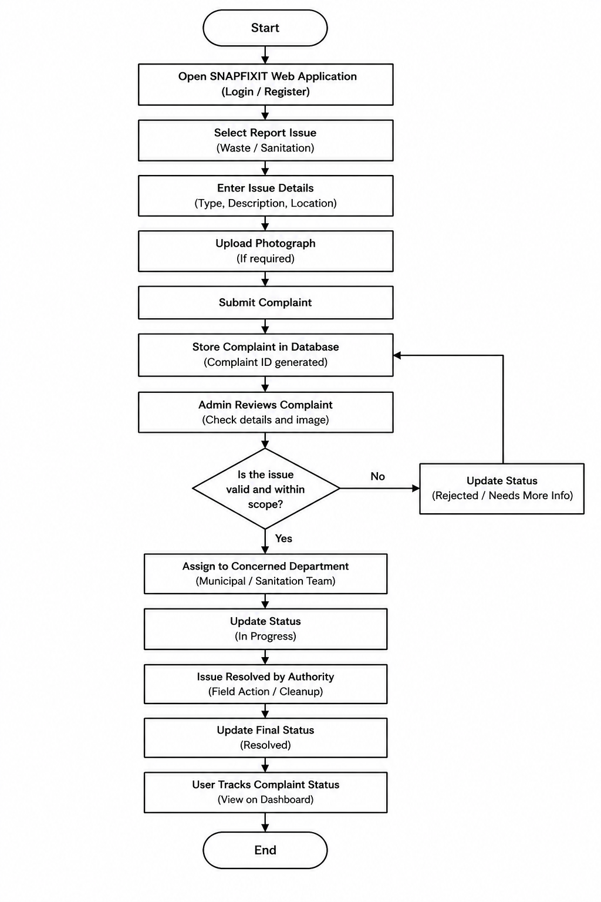
Fig.3.1Flowchart of SNAPFIXIT Smart Waste and Sanitation Issue Reporting System

Fig. 3.1: Working of Principle on Augmented Reality in Education
The working principle of the SNAPFIXIT system explains how users can report waste management and sanitation problems and how the concerned authorities can manage and resolve these complaints.
1. Open SNAPFIXIT System: The user opens the SNAPFIXIT web application using a computer or mobile device.
2. User Registration and Login: The user registers on the system or logs in using existing credentials.
3. Select Issue Type: The user selects the type of problem, such as overflowing dustbins, waste accumulation, blocked drains, or unclean public areas.
4. Enter Complaint Details: The user enters the issue description and location details to explain the problem.
5. Upload Photograph: The user uploads a photograph of the affected area, if this feature is available.
6. Submit Complaint: The user submits the complaint through the web application.
7. Store Complaint in Database: The system stores the complaint details in the database for further processing.
8. Admin Reviews Complaint: The administrator checks the submitted complaint and verifies the available information.
9. Update Complaint Status: The administrator updates the complaint status according to its progress, such as Pending, In Progress, or Resolved.
10. Resolve the Issue: The concerned authority takes the necessary action to resolve the reported waste or sanitation problem.
11. Track Complaint Status: The user checks the complaint status through the system, if status tracking is implemented.
12. End: The process ends when the complaint has been processed and its final status is updated.

2.System Architecture and Main Components:
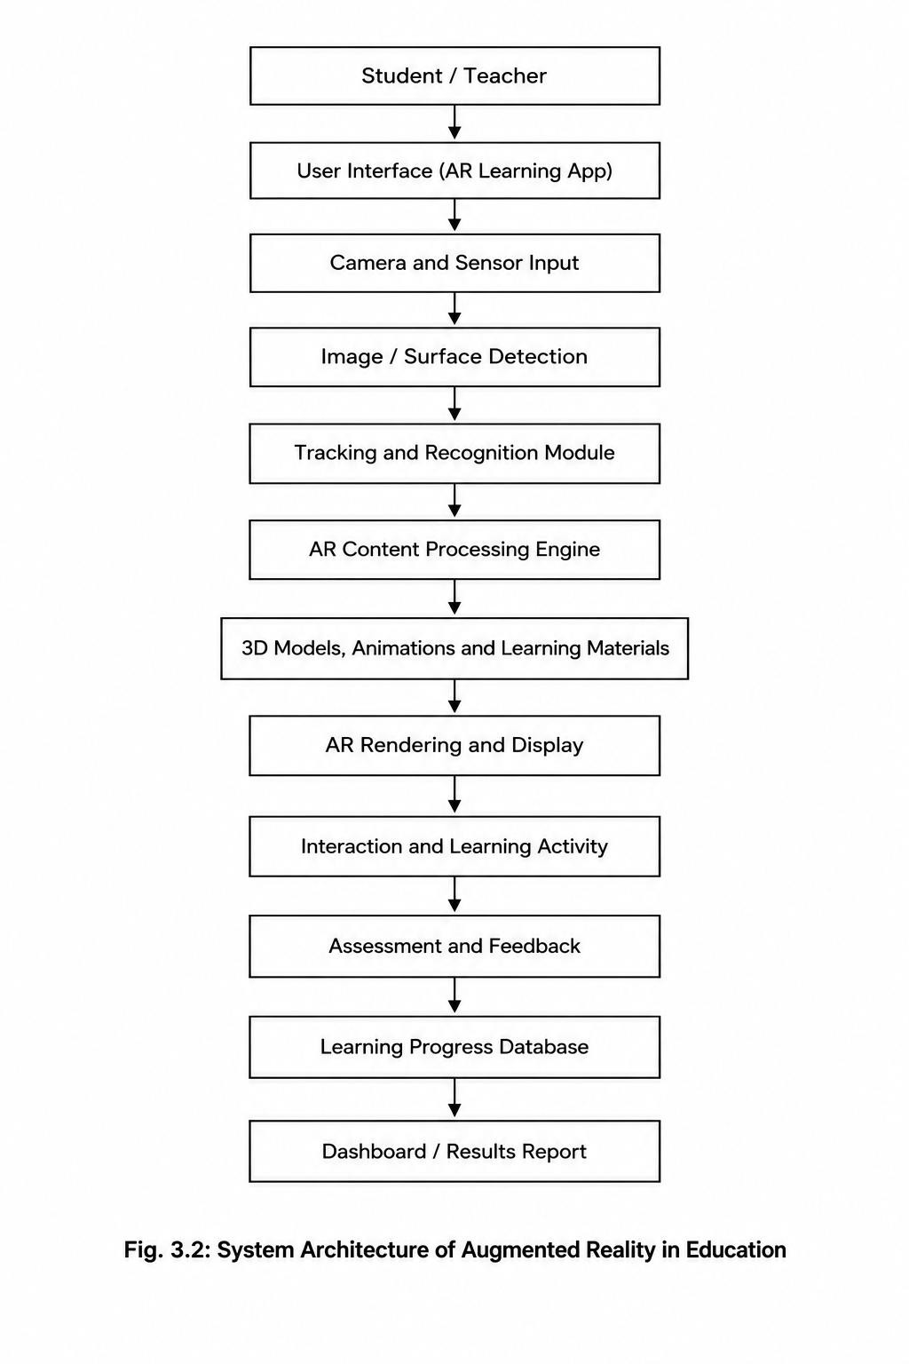
The main components of an Augmented Reality (AR) Education System include the User Interface, Camera and Sensors, Image Detection Module, Tracking and Recognition Module, AR Content Processing Engine, 3D Models and Animations, AR Rendering and Display Module, Assessment and Feedback Module, and Learning Progress Database.
These components work together to combine virtual educational content with the real world environment, provide interactive learning experiences, assess student understanding, and display learning results.
- Technologies and Techniques Used:
Augmented Reality in Education can be developed using technologies such as Augmented Reality (AR), Artificial Intelligence (AI), computer vision, 3D modelling, mobile applications, cameras, sensors, and cloud databases. The camera captures the real-world environment, while image detection and tracking techniques identify objects or surfaces. The AR processing engine loads educational content, such as 3D models, animations, and text. Rendering technology overlays the virtual content onto the real-world view. The final technology selection depends on the project requirements, available devices, and learning objectives.
- Example of Augmented Reality in Education:
Consider a classroom where students are learning about the human body, the solar system, or the structure of a plant. Using an AR application on a smartphone or tablet, students can view interactive 3D models of these topics. For example, when studying the solar system, students can explore virtual planets, observe their positions, and rotate the models to understand their structure. This makes complex concepts easier to visualize and helps improve student engagement and understanding.
- Interactive Learning and Student Assessment:
The AR education system displays virtual educational content through a mobile application or other compatible device. Students can interact with 3D models, animations, and virtual objects to explore different concepts. The application may provide quizzes, exercises, and feedback to assess student understanding. Learning progress and assessment results can be stored in a database and displayed on a dashboard, if these features are supported by the application. This process can make learning more engaging, improve visualization, and help students understand difficult concepts more effectively.

CHAPTER 4

ADVANTAGES AND DISADVANTAGES
4.1 Advantages of SNAPFIXIT
SNAPFIXIT is a web-based waste management and sanitation issue reporting system designed to simplify the process of reporting cleanliness-related problems. It provides a digital platform where users can submit complaints and administrators can manage complaint records. The major advantages of the SNAPFIXIT system are explained below.
- Easy Complaint Registration:
SNAPFIXIT provides a simple and user-friendly interface for reporting waste management and sanitation problems. Users can enter complaint details through the web application without depending entirely on traditional complaint registration methods.

- Saves Time and Effort:
The system reduces the time and effort required to report sanitation problems. Users can submit complaints online instead of visiting the concerned office personally to register every issue.

- Photograph Upload Facility:
Users can upload photographs of affected areas, such as overflowing dustbins, accumulated garbage, or unclean public spaces. These photographs help the administrator understand the nature and seriousness of the reported problem.

- Centralized Complaint Management:
The system maintains complaint information in a centralized database. This makes it easier to store, retrieve, organize, and manage complaint records whenever required.

- Improved Complaint Monitoring:
SNAPFIXIT allows administrators to review submitted complaints and monitor their progress. If complaint status tracking is implemented, users can also check whether their complaints are pending, in progress, or resolved.

- Better Communication and Coordination:
The system provides a common platform for users and administrators to manage sanitation complaints. Organized complaint records can help the concerned authorities identify reported issues and coordinate the necessary actions.

- Promotes Cleanliness and Hygiene:
By making it easier to report sanitation problems, SNAPFIXIT encourages people to participate in maintaining clean public spaces. Timely attention to reported problems can help improve environmental cleanliness and public hygiene.

- Reduces Paperwork:
Digital complaint registration reduces the need to maintain every complaint in physical registers. Electronic records are easier to organize and retrieve, which can simplify administrative work.

- Transparency in Complaint Handling:
Maintaining digital records and updating complaint statuses can improve transparency in the complaint management process. Users can monitor the progress of their complaints when status tracking is available.

- Easy Accessibility:
As a web-based application, SNAPFIXIT can be accessed through a compatible device and web browser with an internet connection. This makes online complaint registration convenient for users in different locations.

- Better Record Maintenance:
The system helps maintain important information, including complaint descriptions, issue categories, submission dates, photographs, and location details, depending on the implemented features. These records can support future reference and analysis.

- Supports Efficient Administration:
The administrator can view and manage complaints through a common interface. This helps organize reported problems and reduces the difficulty of handling scattered or unorganized complaint information.

- Disadvantages of SNAPFIXI:

Although SNAPFIXIT offers several benefits, it also has certain limitations. These limitations are related to internet connectivity, technical maintenance, data accuracy, and the actions required from the concerned authorities.

- Internet Dependency:
SNAPFIXIT is a web-based system, so users generally require an internet connection to access the application and submit complaints. People living in areas with poor connectivity may experience difficulty using the system.

- Technical Problems:
The system may occasionally experience technical issues, such as server failures, software errors, slow loading, or database connectivity problems. Such issues can temporarily interrupt complaint registration and management.

- Incorrect Complaint Information:
The accuracy of the complaint records depends on the information provided by users. If users enter incorrect descriptions, select the wrong issue category, or provide an inaccurate location, the administrator may find it difficult to identify the actual problem.

- Delay in Complaint Resolution:
SNAPFIXIT can help register and organize complaints, but it cannot independently guarantee that every problem will be resolved immediately. Resolution depends on the availability, response, and actions of the concerned authorities.

- Data Security and Privacy:
The system may store personal information, login credentials, photographs, and complaint details. Appropriate security measures are necessary to prevent unauthorized access, misuse, or disclosure of this information.

- Regular Maintenance Required:
The web application and its database require regular maintenance to ensure proper functioning. Software updates, error correction, database management, and security improvements may require technical knowledge and resources.

- Limited Digital Awareness:
Some users may not be familiar with web applications, online forms, or digital complaint registration. Such users may require guidance before they can use the system effectively.

- Dependence on Administrative Action:
The effectiveness of SNAPFIXIT depends on whether administrators review complaints and update their status regularly. If complaints are not monitored properly, the system may not achieve its intended purpose.

- Photograph and Data Storage Requirements:
If users upload many photographs, the system may require additional storage capacity. Large image files can also increase loading time and require suitable database and file management practices.

- Limited Functionality:
The performance of SNAPFIXIT depends on the features actually implemented in the application. Advanced facilities such as automatic location detection, notifications, maps, and automated complaint assignment may not be available in the basic version.

- Requires User Participation:
The system can collect useful complaint information only when users actively report the problems they observe. If people do not use the application, many sanitation issues may remain unreported

Conclusion
SNAPFIXIT is a web-based waste management and sanitation issue reporting system developed to make the process of reporting and managing cleanliness-related problems easier and more systematic. The main objective of this project is to provide a digital platform where users can report problems such as overflowing dustbins, garbage accumulation, blocked drains, and unclean public areas.
The system allows users to submit complaints by providing relevant details, such as the type of issue, description, location, and photographs, depending on the available features. The submitted complaint records can be stored in a database and managed through an administrator dashboard. The administrator can review complaints, maintain records, and update their status according to the progress of the resolution process.
SNAPFIXIT helps reduce manual paperwork, improves complaint record management, and provides a convenient way to communicate sanitation-related issues to the concerned authorities. It also encourages citizens to participate actively in maintaining cleanliness and improving their surroundings. By maintaining organized complaint records, the system can support better monitoring and more transparent complaint management.
Although the system depends on internet connectivity, accurate information, regular maintenance, and timely action by the concerned authorities, it provides a useful approach to digital sanitation management. In the future, the system can be enhanced by adding features such as GPS-based location detection, email or SMS notifications, interactive maps, and advanced complaint analysis.
In conclusion, SNAPFIXIT aims to make waste management and sanitation complaint handling more accessible, organized, and efficient. It can serve as a useful step towards cleaner public spaces, improved sanitation management, and greater citizen participation in building a clean and healthy environment.

CHAPTER 5

PROJECT INITIATION
5.1 Description of Problem Statement
Many areas face waste management and sanitation problems such as overflowing dustbins, garbage accumulation, blocked drains, and unclean public places. These problems can affect environmental cleanliness, public hygiene, and the quality of life of citizens. Traditional complaint methods may involve manual paperwork, delays in communication, and difficulties in maintaining and tracking complaint records. There is a need for a simple and organized system that allows citizens to report sanitation-related problems and provide details about the affected areas. Without a centralized complaint management system, it may become difficult to maintain records, monitor complaint progress, and communicate reported issues to the concerned authorities.
SNAPFIXIT aims to address these problems by providing a web-based platform for reporting and managing waste management and sanitation complaints. Users can submit complaint details, including the issue description and location information, and upload photographs where supported. The system helps organize complaint records and enables administrators to review complaints and update their status. Therefore, the project focuses on making sanitation complaint reporting more accessible, organized, and efficient.
5.2 Scope and Objectives
a) Scope of the Study:
This project focuses on a web-based waste management and sanitation issue reporting system. It considers complaint registration, issue descriptions, location details, photograph uploads where implemented, database management, and administrative complaint handling.
The system is intended for citizens who want to report sanitation problems and administrators who manage submitted complaints. It supports the maintenance of digital complaint records and monitoring of complaint status, depending on the implemented features. The project does not claim to perform physical waste collection or guarantee immediate complaint resolution. Advanced features such as GPS-based location detection, interactive maps, and automated notifications may be considered for future development.
b) Objectives:
- To develop a web-based system for reporting waste management and sanitation problems.
- To identify and document common sanitation issues such as garbage accumulation and overflowing dustbins.
- To provide a user-friendly interface for submitting complaints.
- To support the submission of complaint descriptions, location details, and photographs where implemented.
- To maintain complaint records in an organized manner.
- To provide an administrative interface for reviewing and managing complaints.
- To support complaint status updates and monitoring.
- To reduce manual paperwork and improve complaint record management.
- To encourage citizen participation in maintaining cleanliness.
- To identify future improvements for effective sanitation complaint management.

5.3 Stakeholders

Stakeholder | Role / Interest
Citizens / Users | Report waste management and sanitation problems through the web application.
Administrator | Reviews submitted complaints, manages records, and updates complaint status.
Municipal Authorities | Take necessary action to resolve reported sanitation problems.
Web Developers | Designs, develops, tests, and maintains the system.
Database Administrator | Maintains complaint records, database organization, and data security, where applicable.
IT Support Staff | Helps maintain the application and troubleshoot technical issues.
Local Community | Benefits from improved reporting and monitoring of sanitation problems.

Table 5.3: Stakeholders and Their Roles in the SNAPFIXIT System

5.4 Platform / Equipment / Resources Identification
1. Platform
SNAPFIXIT is a web-based application that can be accessed through a compatible web browser. It provides a digital interface for reporting sanitation problems and managing complaint information. A computer or laptop can be used for application development, testing, and maintenance.
2. Equipment
- Computer or laptop for developing and testing the application.
- Smartphone, tablet, or computer for accessing the web application.
- Internet connection for accessing the online system.
- Camera-enabled device for capturing photographs of affected areas, if required.
- Suitable storage resources for application files and complaint-related information.

3.1 Software and Resources

Resource | Example / Option | Purpose
Operating System | Windows, Android, or iOS | Runs development tools or the SNAPFIXIT web application.
Web Development Tools | Visual Studio Code | Used to write, edit, and manage website code.
Programming Languages | HTML, CSS, and JavaScript | Develops the website structure, design, and interactive features.
Database | MySQL, SQLite, or another suitable database, if configured | Stores and manages complaint records and related information.
Testing Resources | Compatible devices and test cases | Checks website functionality, usability, and performance.
Learning Materials | Technical documentation, tutorials, and reference materials | Supports development, troubleshooting, and maintenance.
Human Resources | Project team members, developers, administrators, and users | Helps develop, test, manage, and use the SNAPFIXIT system.

Table 3.1:Software and Resources Required for the SNAPFIXIT System

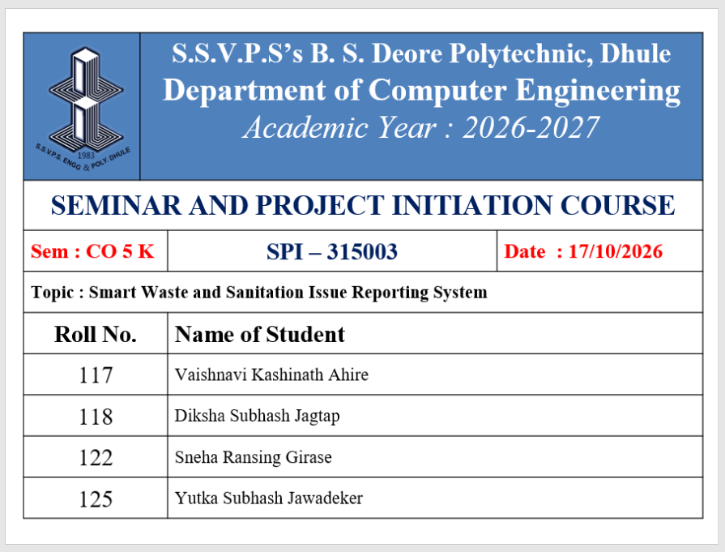
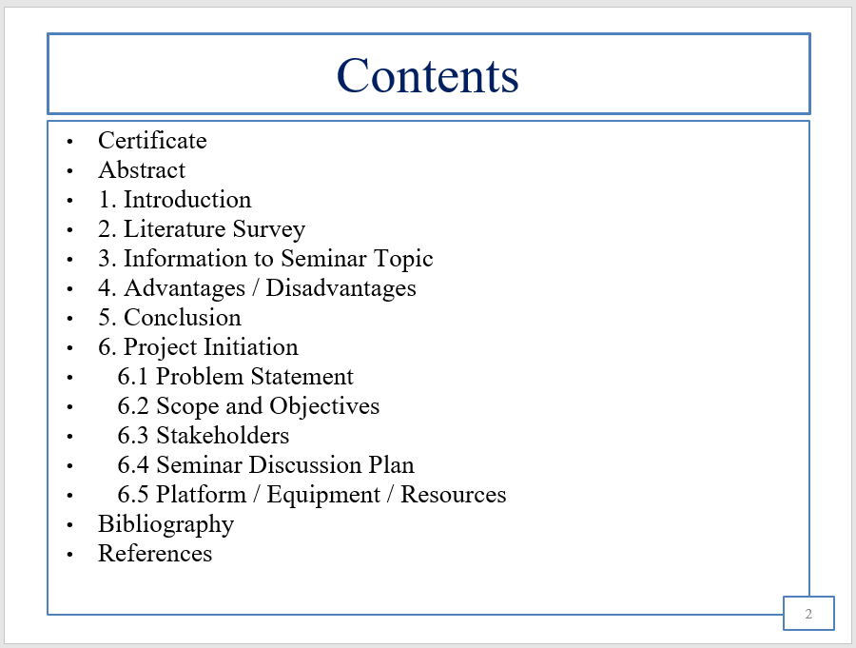

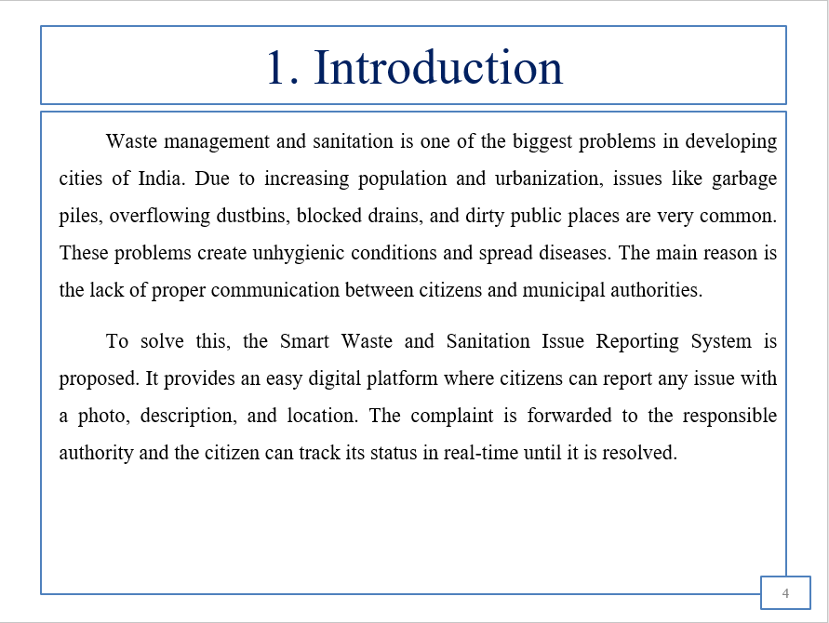
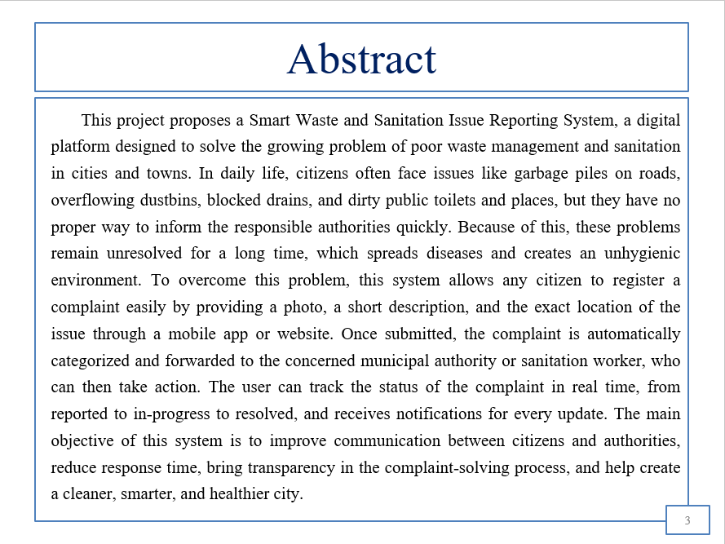

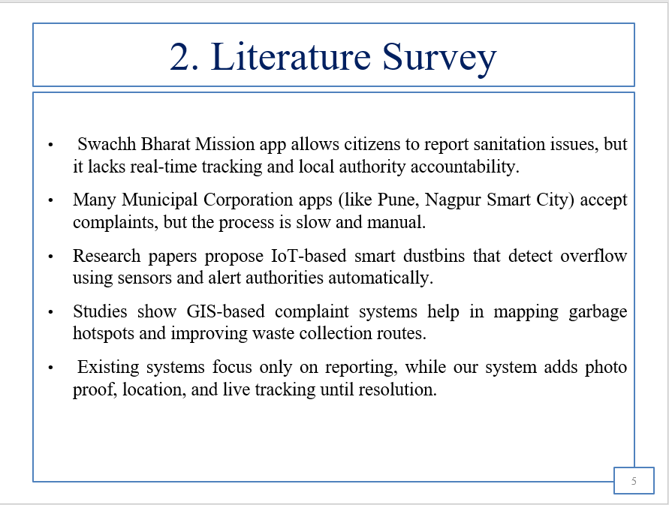

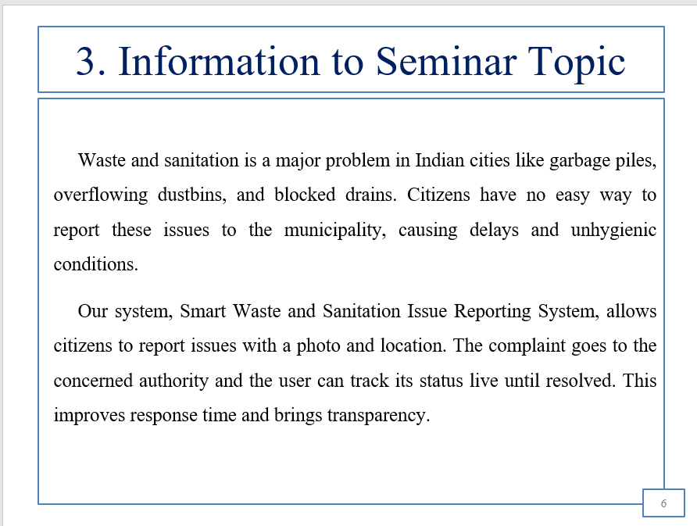

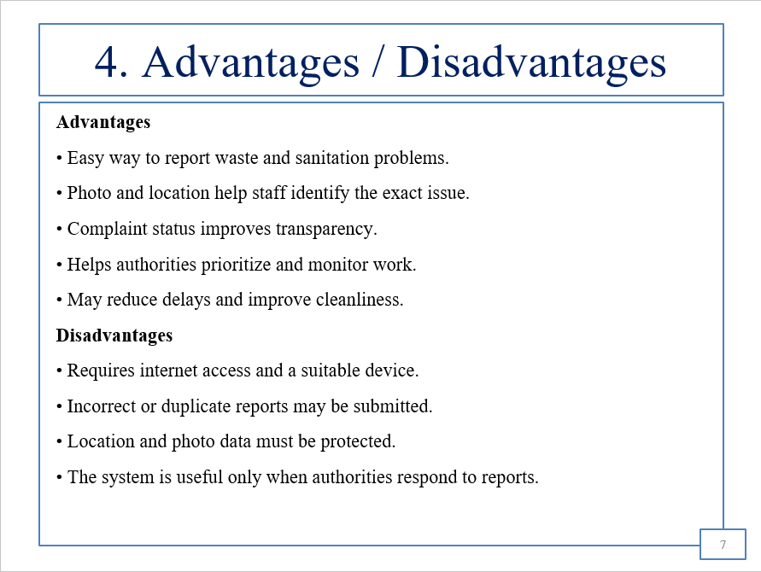

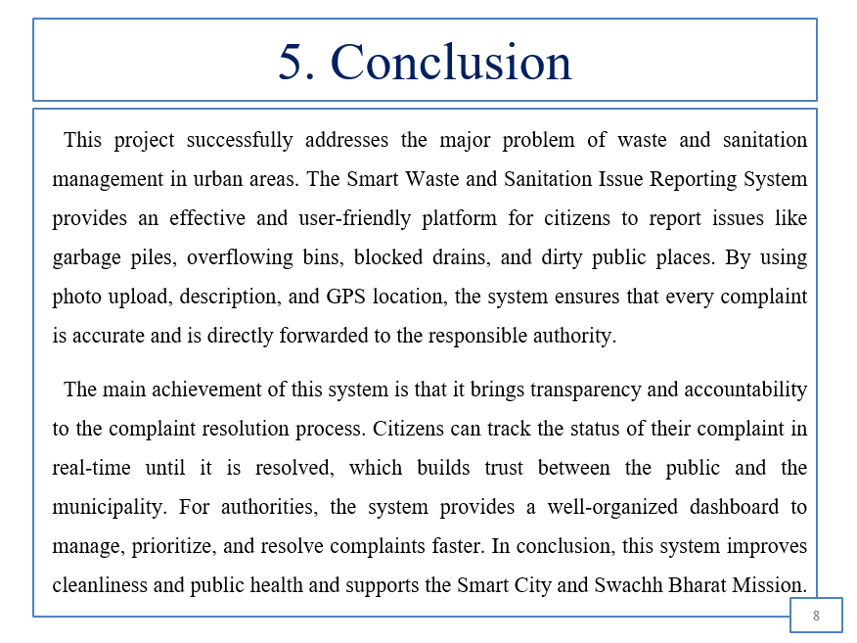

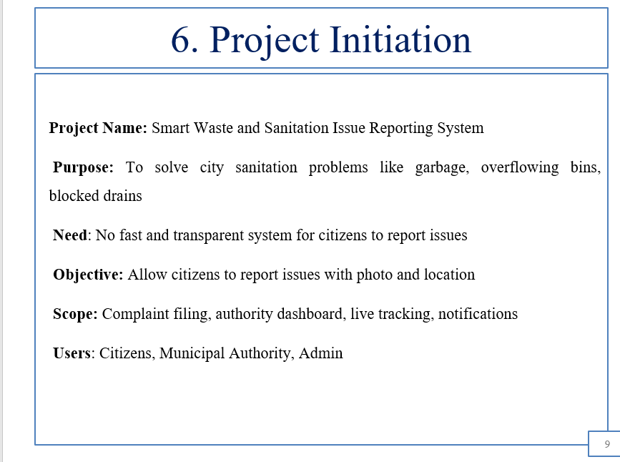

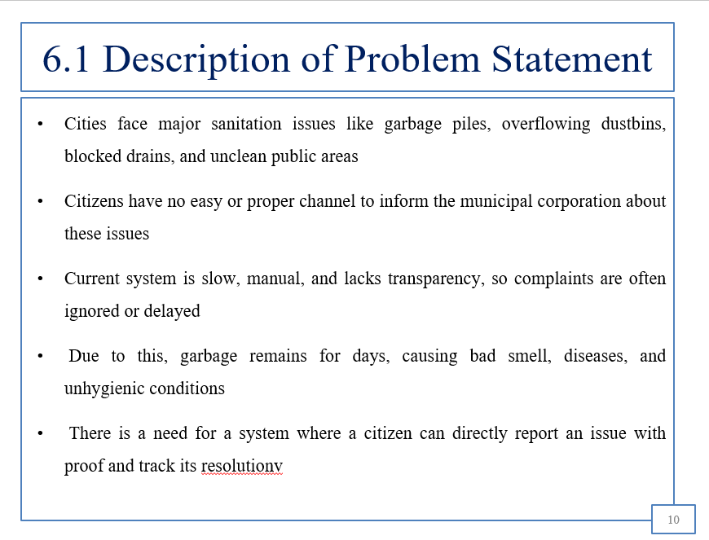

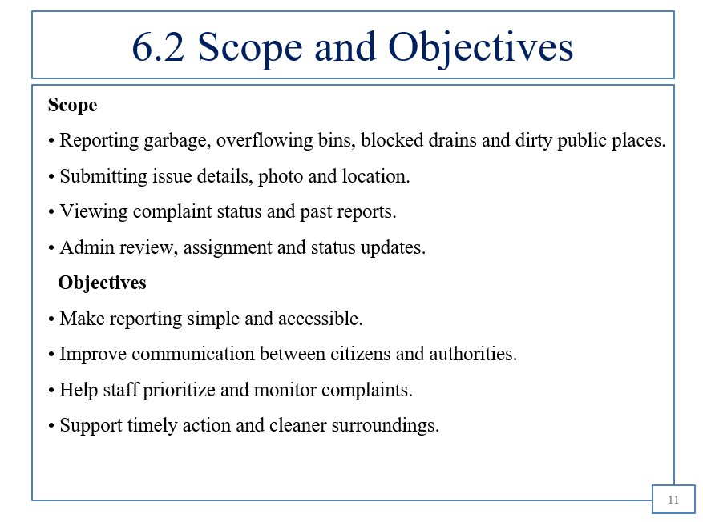

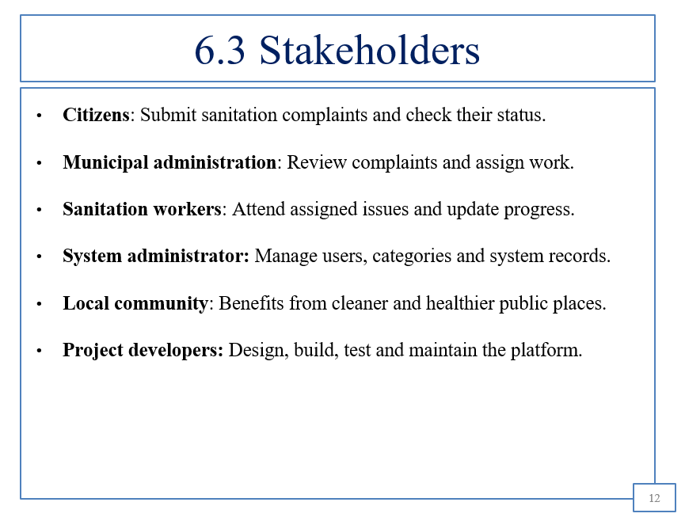

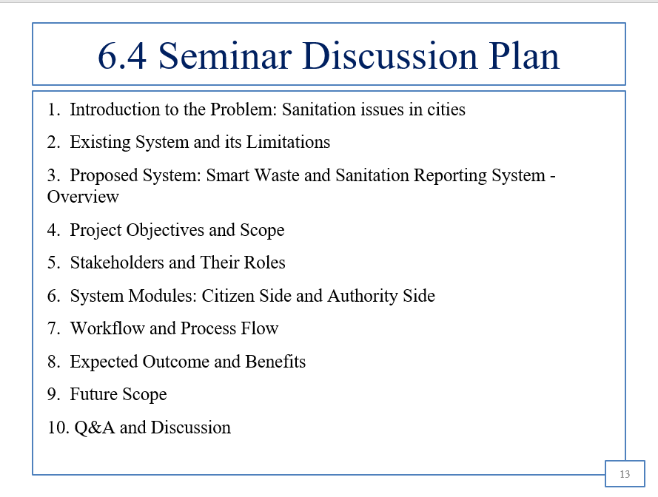

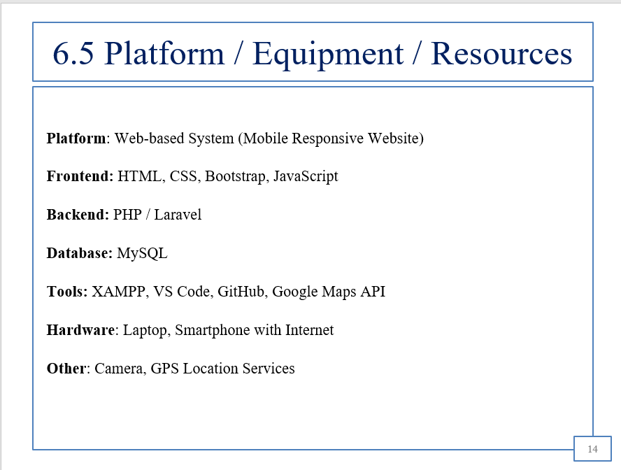

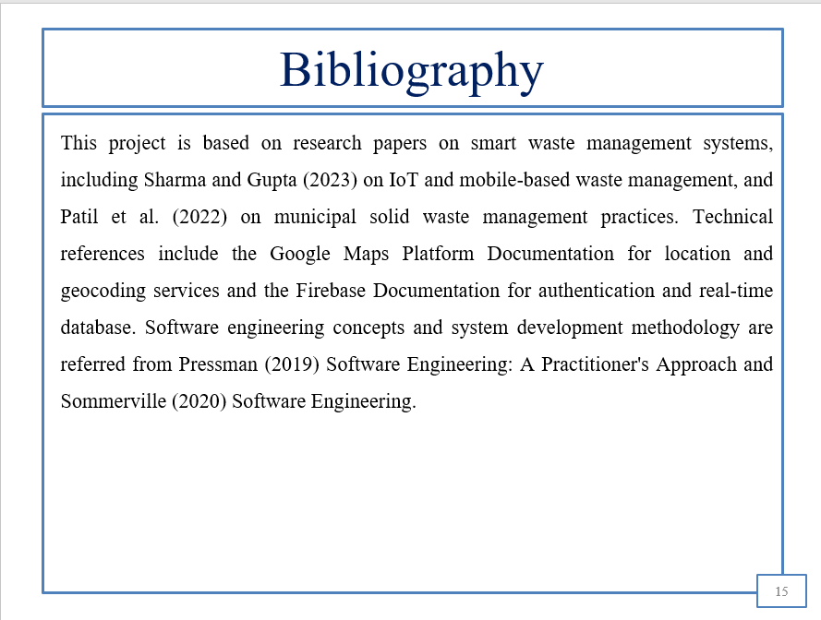

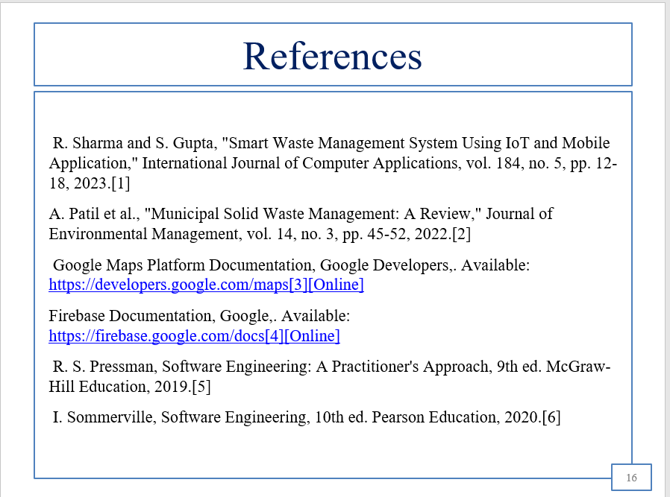

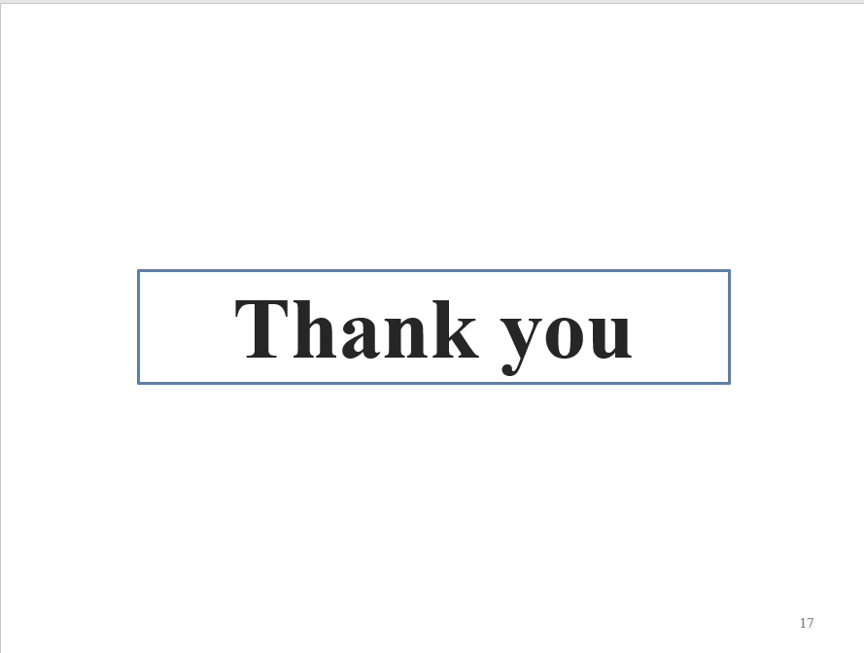

CHAPTER 6

BIBLIOGRAPHY
The following sources are relevant to the topic of Smart Waste and Sanitation Issue Reporting System. These sources provide information about waste management, sanitation, smart city initiatives, and technologies used for developing digital reporting systems.

1. Ministry of Housing and Urban Affairs, Government of India. (n.d.). Swachh Bharat Mission – Urban. https://mohua.gov.in/
2. Central Pollution Control Board. (n.d.). Waste Management. https://cpcb.nic.in/
3. Government of India. (n.d.). Swachh Bharat Mission – Grameen. https://swachhbharatmission.ddws.gov.in/
4. Mozilla Developer Network. (n.d.). HTML, CSS, and JavaScript Documentation. https://developer.mozilla.org/
5. Python Software Foundation. (n.d.). Python Documentation. https://docs.python.org/3/
6. Google Scholar. (n.d.). Research on Smart Waste Management and IoT-Based Waste Monitoring Systems. https://scholar.google.com/
7. Ministry of Housing and Urban Affairs, Government of India. (n.d.). Smart Cities Mission. https://smartcities.gov.in/

CHAPER 7

REFERENCES
1. Ministry of Housing and Urban Affairs, Government of India. Swachh Bharat Mission – Urban. https://mohua.gov.in/
2. Central Pollution Control Board (CPCB). Waste Management. https://cpcb.nic.in/
3. Swachh Bharat Mission – Grameen, Government of India. https://swachhbharatmission.ddws.gov.in/
4. Mozilla Developer Network (MDN). HTML, CSS and JavaScript Documentation. https://developer.mozilla.org/
5. Python Software Foundation. Python Documentation. https://docs.python.org/3/
6. Google Scholar. Research Papers on Smart Waste Management and IoT-Based Waste Monitoring Systems. / https://scholar.google.com
7. Smart Cities Mission, Government of India. https://smartcities.gov.in/

SEMINAR and PROJECT INITIATION Assessment / Evaluation

Sr. No | Enrollment Number | Seat  Number | Name of student
1 | 25610960017 | 388612 | Yukta Subhash Jawadekar
2 | 25610960007 | 388605 | Diksha Subhash Jagtap
3 | 25610960011 | 388609 | Sneha Ransing Girase
4 | 25610960006 | 388604 | Vaishnavi Kashinath Ahire

Formative Assessment
Sr. No. | Criteria | Weightage | Exam Seat Number
Sr. No. | Criteria | Weightage | 388612 | 388605 | 388609 | 388604
1 | Selection Topic / Theme of seminar | 5
2 | Literature review and data presentation | 5
3 | Quality of Preparation and innovativeness | 5
4 | Q-A handling | 5
5 | Time Management | 5
6 | Seminar Presentation report | 10
7 | Selection of Theme of Problem Statement and its innovativeness | 5
8 | Stages of development of Action plan | 5
9 | Prototyping | 5
 | Total | 50
 | Scaled to 25

Sign :
Name : ---------------------------------------
(Course Expert/s)

